User Setting Manual

# CONTENTS

**1 Read version information 3**

**2 General settings 4**

**2.1 Factory Default 4**

**2.2 URL code 4**

**3 Interface 5**

**3.1 RS232 5**

**3.2 USB HID-KBW 7**

**3.2.2.1 Output data encoding format 7**

**3.3 USB HID-POS 11**

**3.4 USB COM 11**

**4 Scan mode 11**

**4.1 Manual mode 11**

**4.2 Continuous mode 11**

**4.3 Auto-sensing mode 12**

**5 Lighting and aiming 15**

**5.1 Lighting 15**

**5.2 Aiming 15**

**6 Output prompts 16**

**6.1 Sound prompts 16**

**6.2 All alert tones 17**

**6.3 Startup tone 17**

**6.4 Reading prompt tone 17**

**6.5 Prefix 19**

**6.6 Suffix 20**

**6.7 Tail 20**

**7 Barcode inversion setting 21**

**8 Code type enable/disable configuration 22**

**8.1 Full barcode switch 22**

**8.2 EAN-13 23**

**8.3 ISBN 25**

**8.4 EAN-8 25**

**8.5 UPC-A 27**

**8.6 UPC-E 29**

**8.7 Code128 31**

**8.8 Code39 32**

**8.9 Code32 34**

**8.10 Code93 35**

**8.11 CodaBar 35**

**8.12 Interleaved 2 of 5 38**

**8.13 Industrial 2 of 5 40**

**8.14 Matrix 2 of 5 40**

**8.15 Code11 42**

**8.16 MSI-Plessey 43**

**8.17 Micro QR Code 45**

**8.18 QR Code 46**

**8.19 Data Matrix 46**

**8.20 PDF417 47**

**8.21 Micro PDF417 47**

**8.22 Aztec Code 47**

**8.23 Maxi Code 48**

**9 Appendix B: AIM ID List 49**

**10 Appendix C：Code ID List 50**

**11 Appendix D: ASCII code list 51**

**QR code system 54**

**12 Appendix E: Data Codes 56**

**13 Appendix F: Save or Cancel 58**

### 3A4AAE:Read version information

In order to allow the host to quickly read the version information of the current device, you can confirm it through the "Read version information" setting code

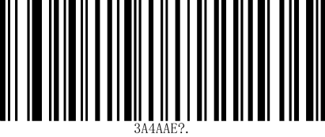

Read version information

# General settings

# Factory Default

By scanning the“Factory Default”barcode,all parameters of the reading engine can be restored to the factory configuration.

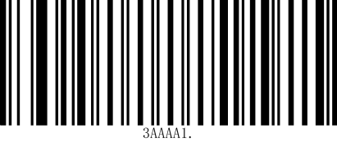

**Factory Default**

# URL code switch

Scan the following setting code to enable or disable URL QR code reading

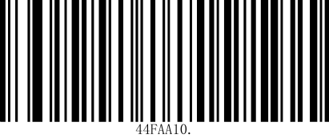

**Allow URL code reading**

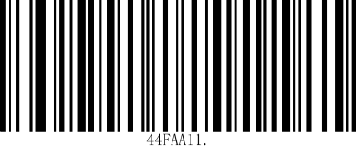

**\*Prohibit reading URL code**

# Interface

The reading engine provides a serial communication interface to communicate with the host. Through the communication interface, you can receive reading data, issue commands to control the reading engine, and change the function parameters of the reading engine.

## RS232 interface

The serial communication interface is a common way to connect the recognition engine and the host device (such as PC, POS and other devices). When the recognition engine and the host are connected using a serial line, the system uses the serial communication mode by default. When using the serial communication interface, the communication parameter configuration between the recognition engine and the host device must be completely matched to ensure smooth communication and correct content.

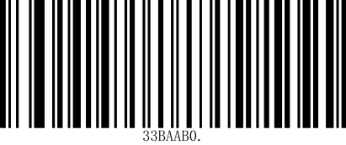

**Serial port output**

The default serial communication parameters of the scanning engine are shown in Table 3-1. Among them, the baud rate of the scanning engine can be modified through the serial port command, but the other parameters cannot be modified.

Table 3-1 Default serial communication parameters

|  |  |
| --- | --- |
| parameter | default |
| Serial communication type | Standard RS-232 |
| Baud rate | 115200 |
| Verify | no |
| Data bits | 8 |
| Stop bits | 1 |
| Hardware flow control | no |

### Serial port baud rate setting

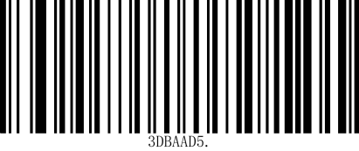

**9600bps**

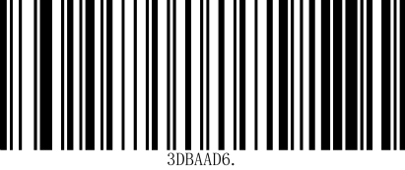

**19200bps**

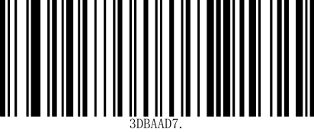

**38400bps**

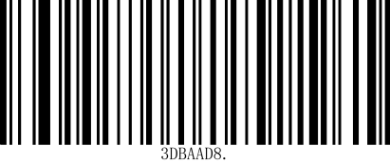

**57600bps**

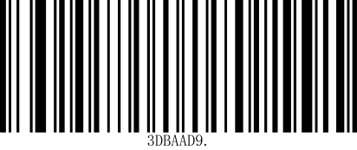

**115200bps**

### Serial port check bit configuration

Customers can modify the parity bit of the serial port by scanning the following setting code

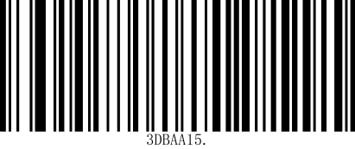

8 data bits, 1 stop character, even parity bit

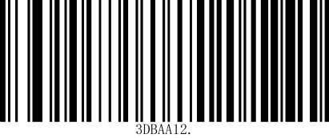

8 Data bits, 1 stop character, no parity bit

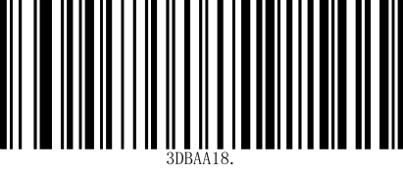

8 data bits, 1 stop character, odd parity bit

## USB HID-KBW

### HID-KBW Equipment

When the device is used as a HID device, you can scan the following setup code to select the HID-KBW device class mode

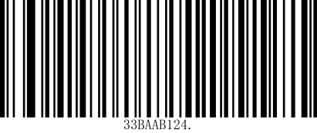

**\*HID-KBW**

### Chinese encoding format

* + - 1. **Output data encoding format**

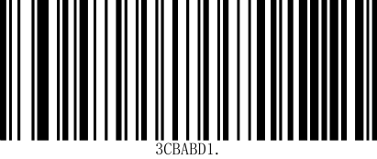

**Output data encoding format**

**GBK**

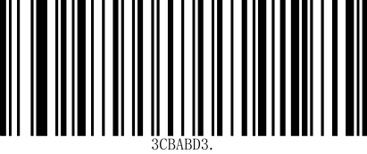

**Output data encoding format UTF8**

### Case Conversion

The following setting code configuration can realize the conversion of uppercase and lowercase letters A~Z

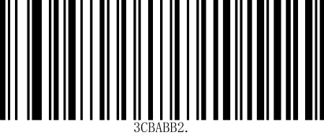

lower case

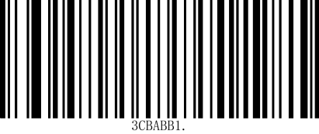

capital

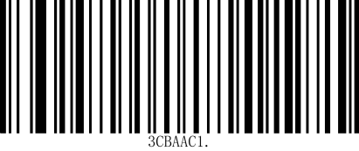

Convert uppercase and lowercase



No change

### Keyboard settings for different countries

In order to allow hosts in various countries to use the device, you can set it up by scanning the "keyboard" setting code of the corresponding country.

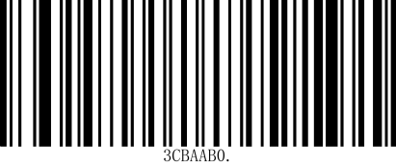

**\*USA**

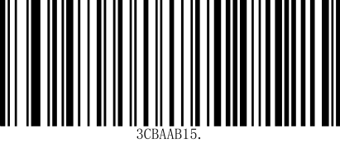

**Czech Republic**

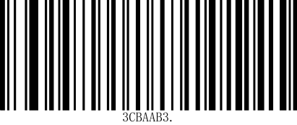

**France**

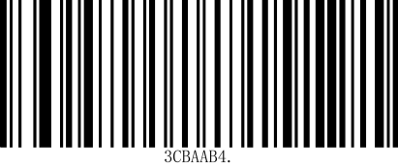

**Germany/Austria**

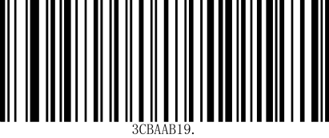

**Hungary**

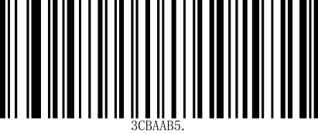

**Italian**

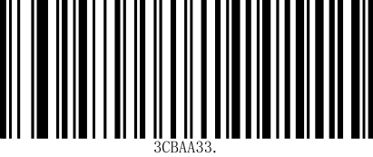

**Japan**

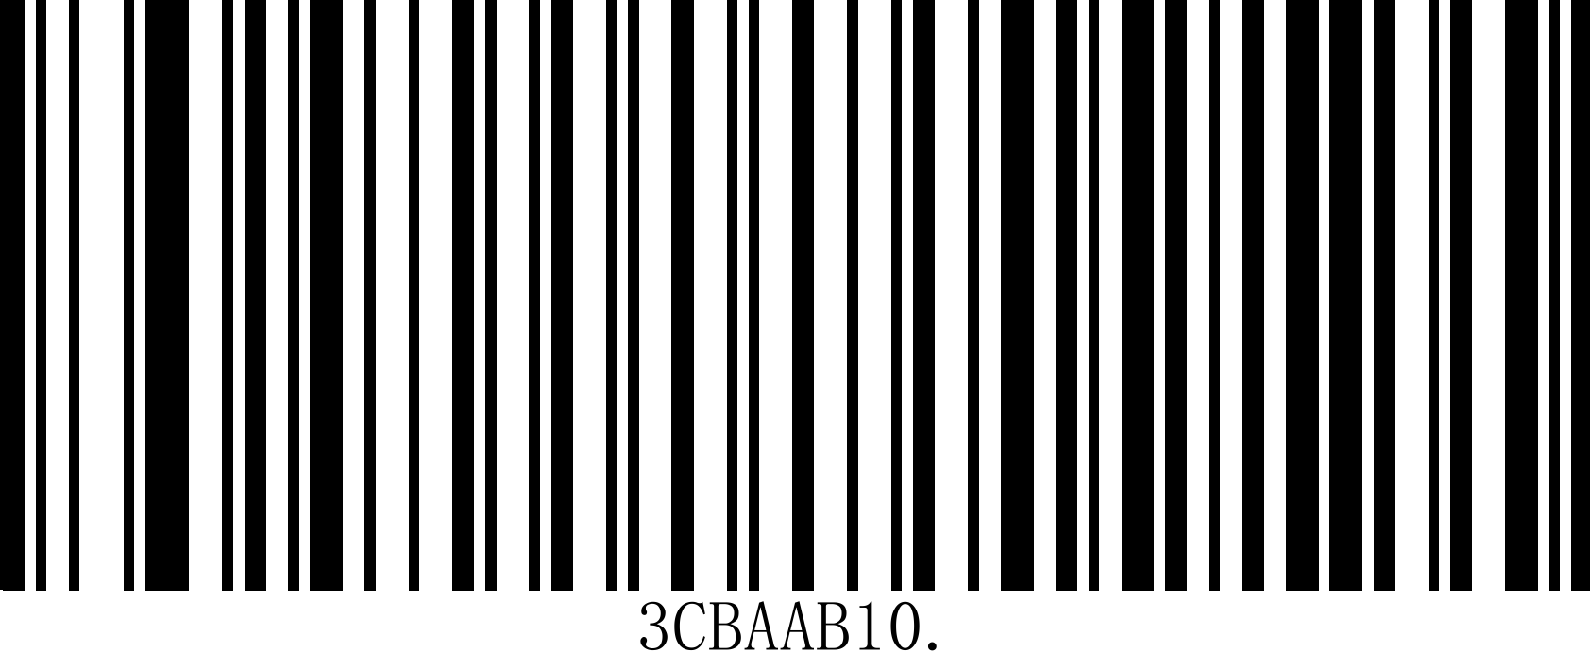

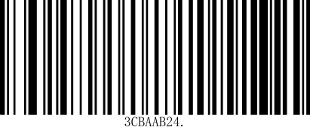

**Türkiye-Q**

**Spanish**

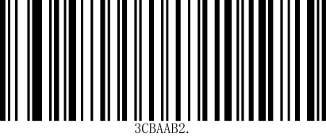

**Finland**

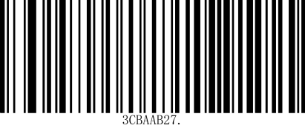

**Türkiye- F**

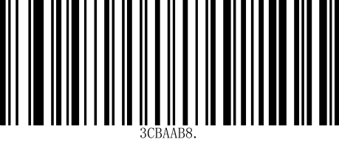

Denmark

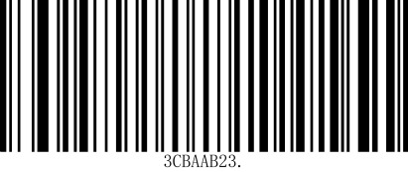



**Spanish**

**Sweden**

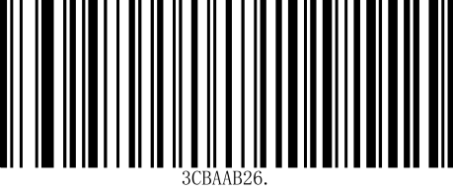

**Russia**

## USB HID-POS

### HID-POS equipment

When the device is used as a HID device, you can scan the following setup code to select the HID-POS device mode.

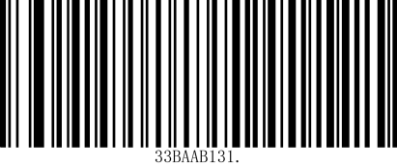

**HID-POS**

## USB -COM

When the scanning engine is connected to the host computer via a USB cable, you can configure the scanning engine to virtual serial port output mode by scanning the following setup code

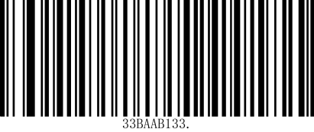

**USB-COM**

# Scanning mode

## Manual mode

### Mode entry

Manual reading mode is the default reading mode. In this mode, the reading engine starts reading the code after the user presses the trigger key, and stops reading the code after the code reading successfully outputs information or the user releases the trigger key (the platform does not support manual mode)

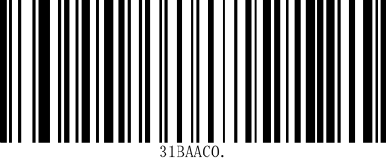

**\*Manual mode**

## Continuous mode

### Mode entry

After the settings are completed, the engine will start reading the code immediately without triggering. When the code reading successfully outputs information or the single code reading time ends, the engine will automatically start the next code reading after waiting for a period of time (which can be set). If the following situations do not occur, the engine will work in a loop as above: During the code reading process, the user can also click the trigger button to manually pause the code reading. Clicking the trigger button again will cause the engine to continue the code reading cycle.

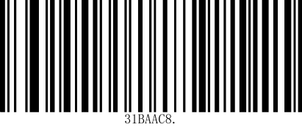

**Continuous mode**

### Reading interval time

This parameter refers to the interval between two consecutive scans, that is, after the last scan is completed (regardless of whether the scan is successful or not), the scan engine will not perform any scans within the set interval until the next scan is completed. The setting range of the scan interval is 0~25.5 seconds, with a step length of 0.1 seconds. The default interval is 1.0 seconds.

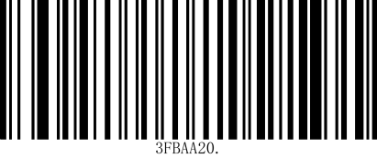

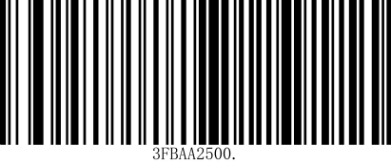

**500ms**

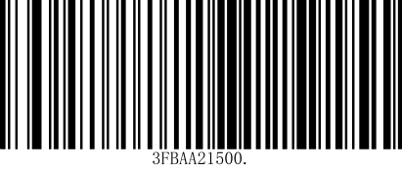

**1500ms**

No interval

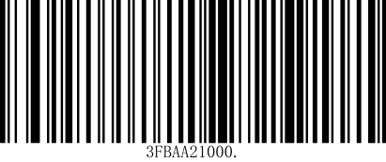

**\*1000ms**

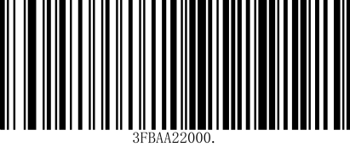

**2000ms**

### Delay time for reading the same barcode

同ame as the setting method in 4.3.3

## Sensing Mode

### Mode entry

After the settings are completed, the reading engine immediately starts to monitor the brightness of the surrounding environment without triggering. When the scene changes, the reading engine waits for the set image stabilization time to end before starting to read the code. If the following situations do not occur, the reading engine will work in a cycle as above: If no barcode is scanned within the single reading time, the reading engine will automatically pause reading and enter the monitoring state. In the inductive reading mode, the reading engine can also start reading the code after the user presses the trigger button, and continue to monitor the brightness of the surrounding environment when the code reading successfully outputs information or the user releases the trigger button.

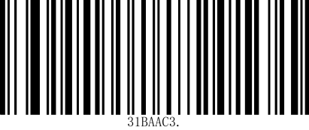

**Sensing Mode**

### Sensitivity

Sensitivity refers to the degree of scene change detected in the sensing reading mode. When the reading engine determines that the scene change degree meets the requirements, it will switch from the monitoring state to the reading state.

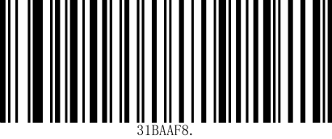

**Low**

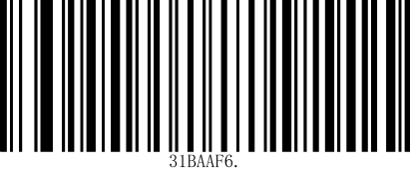

**Medium**

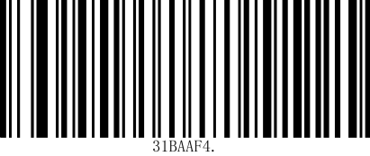

**\*High**

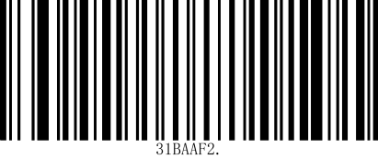

**Extra high**

### Delay time for reading the same barcode

When the same barcode reading delay is enabled, the same barcode reading delay time can be set through the following setting code.

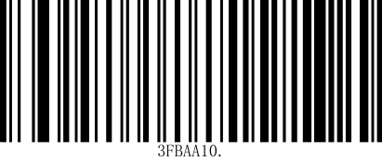

**No delay**

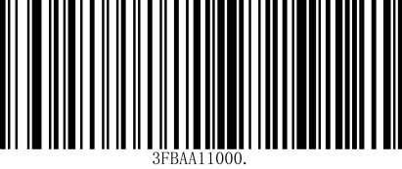

**\*1000ms**

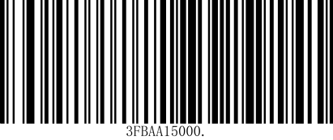

**5000ms**

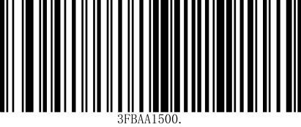

**500ms**

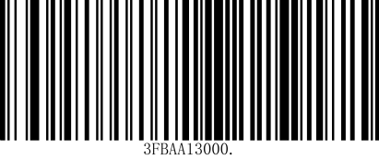

**3000ms**

# Lighting and aiming

## Lighting

The lighting can provide auxiliary lighting for shooting and reading. The light beam shines on the reading target, improving the reading performance and the adaptability to weak ambient light. Users can set it to one of the following states according to the application environment:

**Normal lighting (default setting): The lighting is on when shooting and reading, and off at other times;**

**No lighting: The lighting will not come on in any situation.**

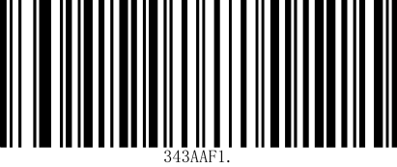

**\*Normal lighting**

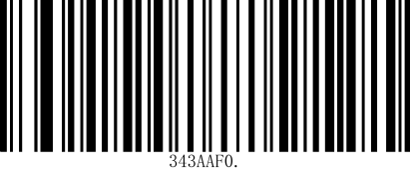

No lighting

## Aiming (not applicable to platforms)

The projected aiming beam helps users find the best reading distance when shooting. Users can choose any of the following modes according to the application environment:

**Aiming Normal (default setting): The scanning engine only projects the aiming beam when shooting and scanning;**

**No Aiming: The aiming beam is off in all situations.**

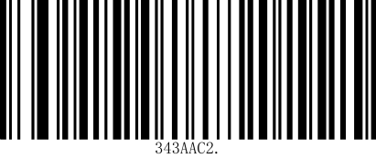

**\*Aiming Normal**

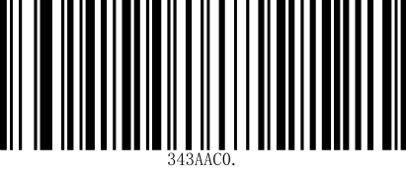

No Aiming

# Prompt Output

## Sound Prompt

Scan the following setting code to set the scanner sound.

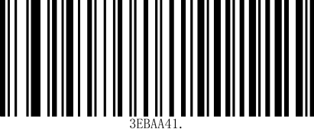

**Low**

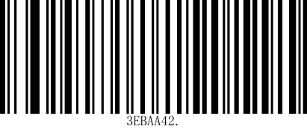

**\*Medium**

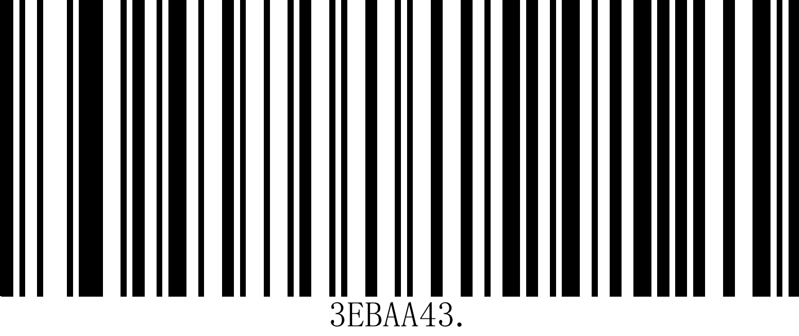

**High**

## All prompt tones

Scan "Enable Mute" to turn off all prompt sounds, and scan "Disable Mute" to cancel the mute setting.

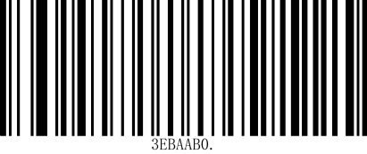

**Enable Mute**

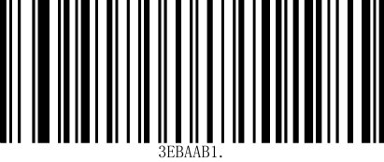

**\*Disable mute**

## Startup sound

Scan "Enable startup sound" to turn on the startup sound. Scan "Disable startup sound" to turn off the startup sound.

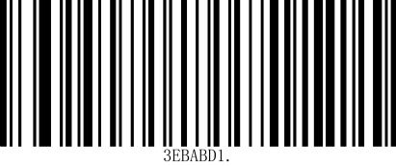

**\*Enable startup tone**

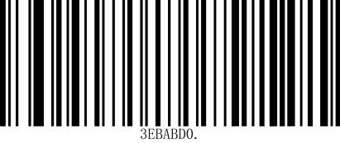

**Disable startup tone**

## Reading prompt tone

The reading prompt tone includes the setting success prompt tone and the scanning code reading success prompt tone.



**\*Enable reminder tone**

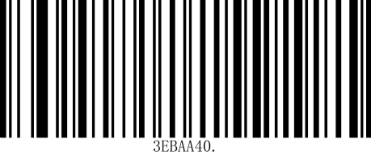

**Disable reminder tone**

### Duration of successful reading prompt tone

Scan “Prompt Tone Duration” to set the duration of the successful reading prompt tone.

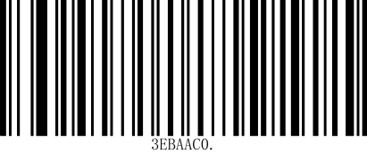

**Long buzzer**

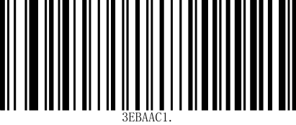

**\*Short beep**

## 前缀Prefix

**添加前后缀说明Add prefix and suffix instructions**

**第一步.扫描“添加前缀”或“添加后缀”条码。The first step Scan the barcode for 'add prefix' or 'add suffix'.**

**第二步.确定要添加前缀或后缀的码制，从码制图表确定 2 位十六进制值。Step two Determine the code system to add a prefix or suffix, and determine the 2-digit hexadecimal value from the code system chart.**

**例如，对于 Code 11，条码类型序号为“h”，Hex ID 为“68”。For example, for Code 11, the barcode type number is "h" and the Hex ID is "68".**

**第三步.扫描本手册附录图表中的 2 个十六进制数字，或扫描 9,9 应用于**

**所有码制。Step three Scan the two hexadecimal digits in the appendix chart of this manual, or scan 9,9 for application all code systems.**

**第四步.从 ASCII 转换表确定前缀/后缀的十六进值。Step four Determine the hexadecimal value of the prefix/suffix from the ASCII conversion table.**

**第五步.扫描本手册附录图表中的 2 位十六进制值。Step five Scan the two hexadecimal values in the appendix chart of this manual.**

**第六步.对每个前缀/后缀字符重复步骤 4 和 5。Step six Repeat steps 4 and 5 for each prefix/suffix character.**

**第八步.扫描“保存”条码退出并保存，或扫描“放弃”条码退出而不保存。重**

**复步骤 1-6，为其他码制添加前缀或后缀。Step 8 Scan the 'Save' barcode to exit and save, or scan the 'Discard' barcode to exit without saving. Repeat steps 1-6 to add prefixes or suffixes to other code systems.**

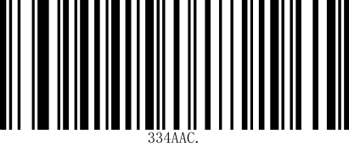

**允许添加前缀Allow prefix addition**

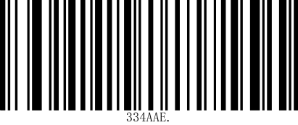

**\*禁止添加前缀*Prohibit adding prefixes**

## 后缀Suffix

Add Suffix

Suffixes are user-defined strings that can be added by scanning the “Allow Suffixes” setting code after decoding the message.

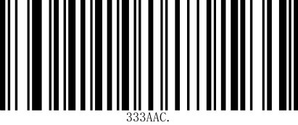

Suffixes are allowed

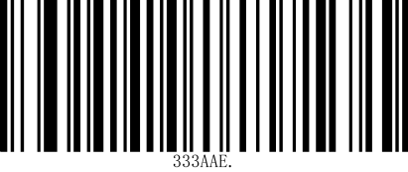

**\***Disable suffixes

## 结束符 Tail

In order to allow the host to quickly distinguish the current decoding results, you can turn on this function.

Scanning “Modify Terminator Suffix” to enable this function, if the reading is successful, the reading engine will add the corresponding terminator after the decoded data.

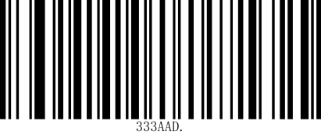

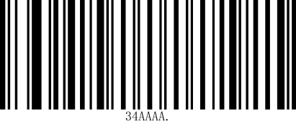

*CR Modify the terminator suffix to CR

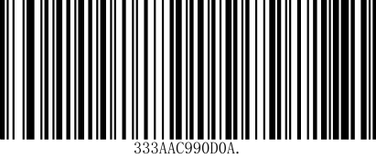Modify the terminator suffix to CRLF close endpoint

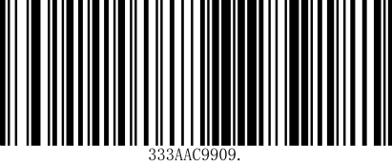

Modify the terminator suffix to TAB

## **7 条码反相设置 Barcode Inversion Setting**

## In some special scenarios, it is possible to configure the recognition of positive and negative phase barcodes by scanning the following setup codes. If this configuration is turned on, the recognition speed will be affected. Please turn it on in the scenarios where it is required.

## 

## **\*Inverted barcodes are not supported**

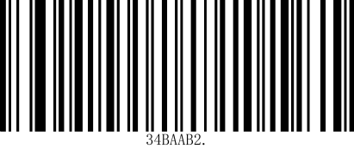

**\*Supports inverted barcodes**

# 条码类型使能/禁止配置

# 8 Barcode Type Enable/Disable Configuration

## 全条码开关 Full Barcode Switch

Scanning the following setup codes will allow or disable reading of all supported barcode types. When all types are disabled, only the setup codes are allowed.

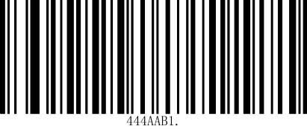

**Allows reading of all types**

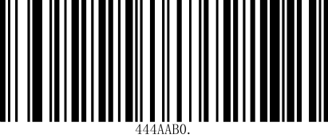

**Prohibit reading of all type**

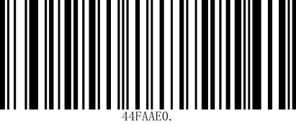

**All 1D code system open**

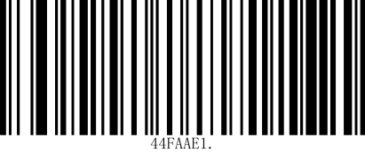

**All 1D system closed**

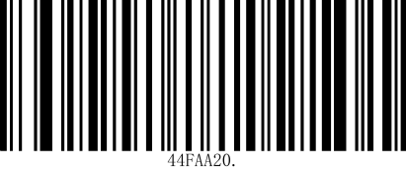

**All QR code system turned on**

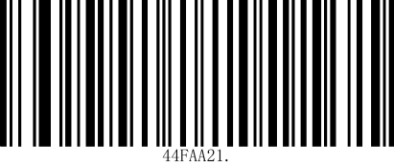

**All QR code system closed**

## EAN-13

### EAN-13 使能 Enabling

Scanning the following setup codes will set the EAN-13 barcode to allow/prohibit reading.

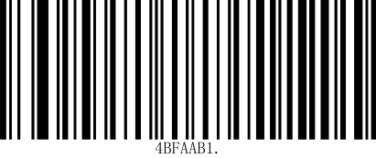

**\*****Permission to read EAN-13**

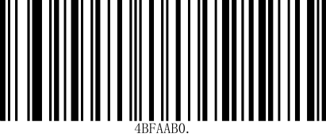

**Prohibition of reading EAM-13**

### EAN-13 传送校验字符 Transmitting the check character

The EAN-13 barcode data is fixed at 13 bytes, of which the last byte is the check character. You can enable or disable the EAN-13 transmission of the check character by scanning the following setup codes.

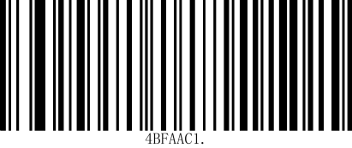

**\*EAN-13 Transmit Check Character**

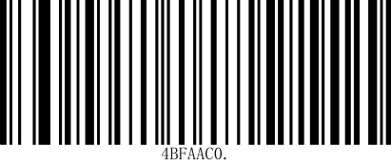

**EAN-13 Do not transmit parity characters**

### EAN-13 附加码设置 Additional code settings

Scan the following setup codes to configure the EAN-13 add-on code to be read or unread.

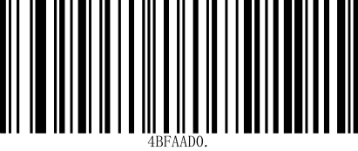

**2-digit add-on code disable**

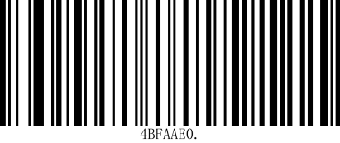

**5-digit add-on code diaable**

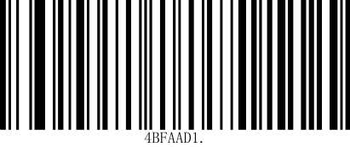

**2-bit additional code enable**

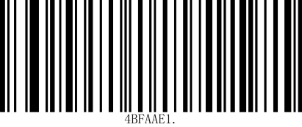

**5-bit additional code enable**

### EAN-13 输出方式 Output methods

Scanning the following setup codes can be configured so that an enabled add-on code must be recognized in order to be output, or an enabled add-on code does not need to be recognized in order to be output.

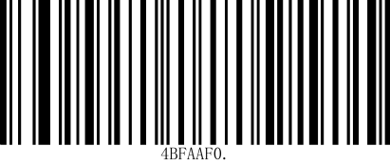

**\*Outputs can be made without the need to recognize the enabled additional code.**

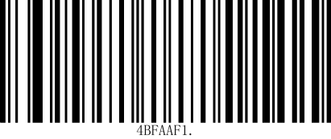

\***Enabled additional codes must bvbe recognized before outputting****.**

## ISBN

### ISBN 使能enable

Scanning the following setup codes will set the ISBN barcode to allow/disallow reading.

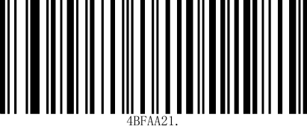

**\*Allows reading of ISBN**

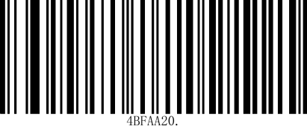

**\*Prohibited reading ISBN**

## EAN-8

### EAN-8 使能 Enabling

Scanning the following setup code will set the EAN-8 barcode to allow/prohibit reading.

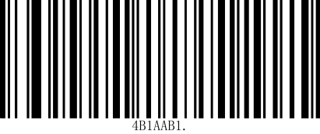

**\*Allows reading of EAN-8**

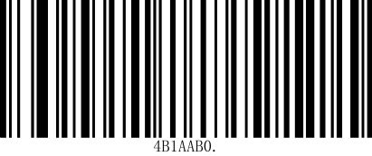

**\*Prohibited reading EAN-8**

### EAN-8 传送校验字符Transmitting the check character

The EAN-8 barcode data is fixed at 8 bytes, of which the last byte is the check character. You can enable or disable the EAN-8 to transmit the check character by scanning the following setup codes.

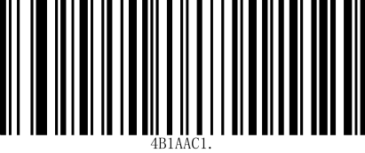

**\*EAN-8 Transmit Check Character**

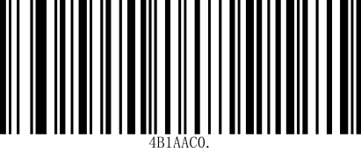

**EAN-8 No checksum character is transmitted**

### EAN-8 附加码设置Surcharge Code Setting

Scan the following setup codes to configure the EAN-8 add-on code to enable or disable.

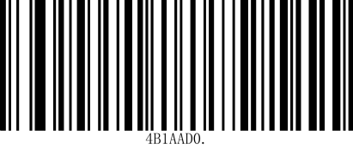

\***2-digit add-on code disable**

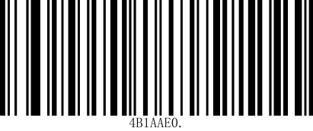

\***5-digit add-on code disable**

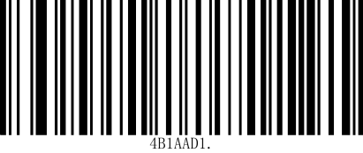

\***2-bit add-on code enable**

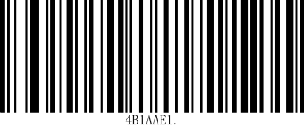

\***5-bit add-on code enable**

### EAN-8 输出方式 Output methods

Scanning the following setup codes can be configured so that an enabled add-on code must be recognized in order to be output, or an enabled add-on code does not need to be recognized in order to be output.

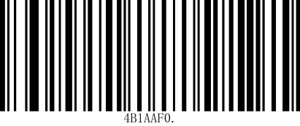

**\*Outputs can be made without the need to recognize the enabled additional code.**

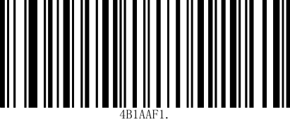

**Enabled additional codes must be recognized before outputting.**

## UPC-A

### UPC-A 使能 Enabling

Scan the following setup codes to set the allow/disallow reading of UPC-A barcodes.

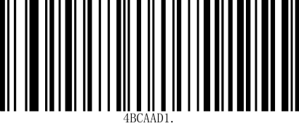

**\*Allows reading UPC-A**

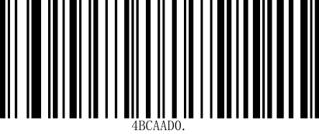

**Prohibited reading UPC-A**

### UPC-A 传送校验字符 Transmitting the check character

The UPC-A barcode data is fixed at 13 bytes, of which the last byte is the check character. You can enable or disable the UPC-E to transmit the check character by scanning the following setup code.

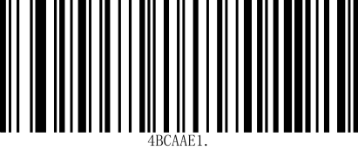

**\*UPC-A Transmit Check Character**

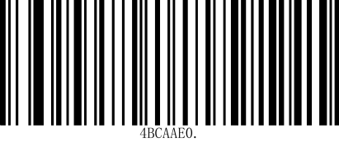

**UPC-A No checksum character is transmitted**

### UPC-A 附加码设置 Additional Code Setting

Scan the following setup codes to configure the UPC-A add-on code enable or disable.

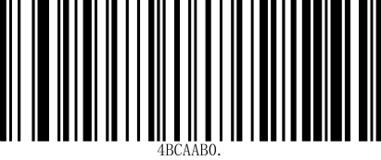

**\*2 digit add-on code disable**

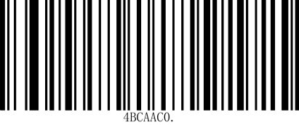

**\*5 digit add-on code disable**

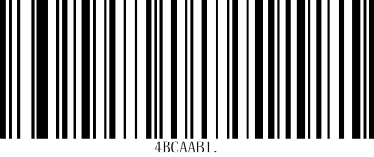

**2-bit add-on code enable**

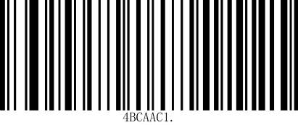

**5-bit add-on code enable**

### UPC-A 输出方式 output method

Scan the following setup codes to configure the output method of the UPC-A.

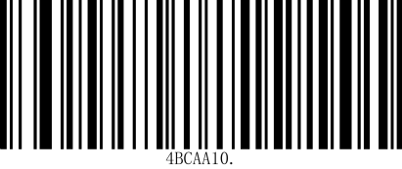

**\*The UPC-A only reads codes without additional codes.**

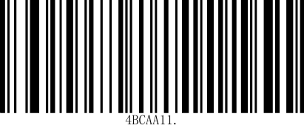

**UPC-A only reads codes with additional codes.**

### UPC-A 转 EAN-13 UPC-A to EAN-13

The UPC-A to EAN-13 conversion can be enabled or disabled by scanning the following setup codes.

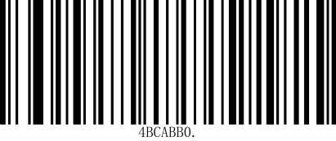

**Enable UPC-A to EAN-13**

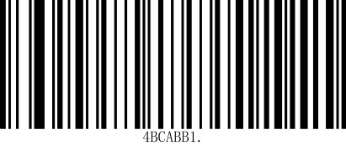

**Disable UPC-A to EAN-13 conversion**

## UPC-E

### UPC-E 使能 Enable

Scanning the following setting codes will set the UPC-E barcode to allow/prohibit reading.

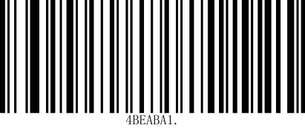

**\*Allow reading of UPC-E**

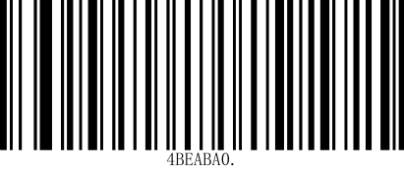

**Prohibit reading UPC-E**

### UPC-E 传送校验字符 Transmission Check Character

The UPC-E barcode data is fixed at 8 bytes, of which the last byte is the check character. You can enable or disable the UPC-E transmit check character function by scanning the following setting codes.

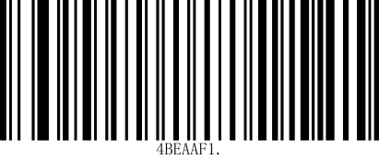

**\*UPC-E Transmit Check Character**

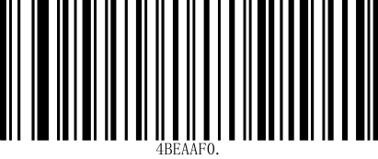

**UPC-E No checksum character is transmitted**

### UPC-E 附加码设置 UPC-E Add-on Code Settings

Scan the following setup codes to configure the UPC-E add-on code enable or disable.

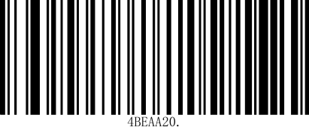

**\*2-bit add-on code disable**

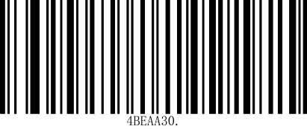

**\*5-bit add-on code disable**

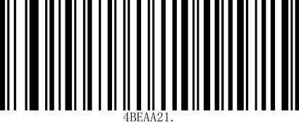

**2-bit add-on code enable**

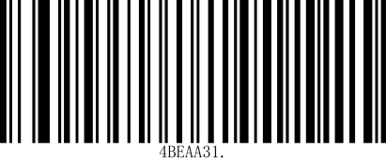

5-**bit add-on code enable**

Scan the following setup codes to configure the UPC-E add-on codes to be output only if they are recognized as enabled, or to be output without recognizing the enabled add-on codes.

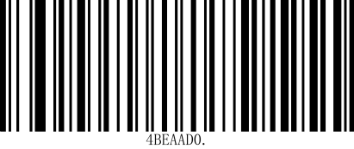

**\*No additional code required**

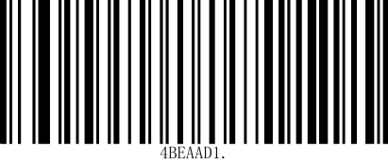

**Additional code required**

### UPC-E 转 UPC-A UPC-E to UPC-A Conversion

The UPC-E to UPC-A conversion can be enabled or disabled by scanning the following setup codes.

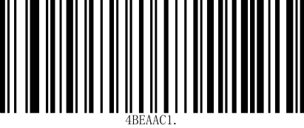

**Enable UPC-E to UPC-A**

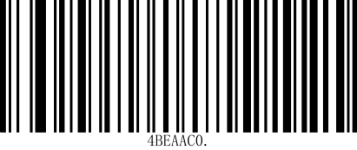

**\*Disable UPC-E to UPC-A.**

## Code128

### Code128 使能 Enable

Scanning the following setup codes will set up the Code128 barcode allow/prohibit reading.

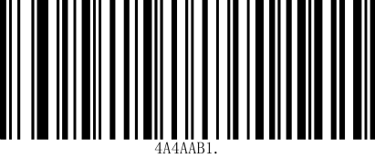

**\*Allow reading Code128**

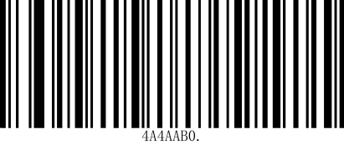

**Code128 reading is prohibited**

### Code128 识读长度设置 Read Length Setting

Scan the following barcodes to change the read length. For additional information, refer to the Read Length description. Minimum and maximum lengths are 0-80; minimum default = 0, maximum default = 80. (NOTE: Scanning the Minimum and Maximum barcode lengths requires scanning the specified barcode length and saving the barcode.)

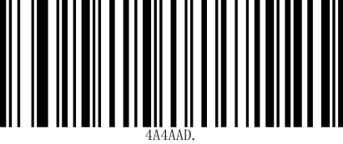

**Code128 Minimum Barcode Length**

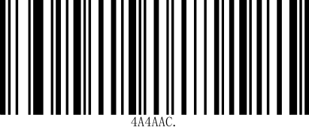

**Code128 Message Maximum Barcode Length**

## Code39

### Code39 使能Enabling

Scanning the following setup codes will set the Code39 barcode allow/prohibit reading.

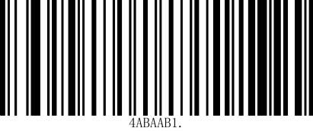

**\*Allow reading of Code39**

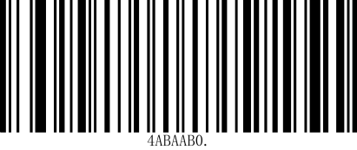

**Prohibit reading of Code39**

### Code39 识读长度设置 Read Length Setting

Scanning the following setting code will set the minimum reading length of Code39 barcode.

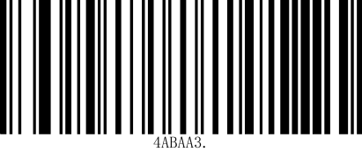

**Code39 Minimum Barcode Length**

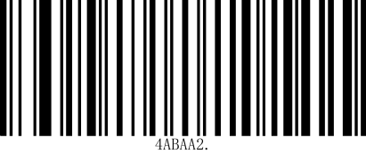

**\*Code39 Maximum Barcode Length**

### Code39 校验设置(Modulo 43) Checksum Setting (Modulo 43)

Code 39 barcode data is not forced to contain the check character, if there is a check character, it must be the last byte of the data. If there is a check character, it must be the last byte of the data. The check character is the value calculated from all the data except the check character, which is used to check whether the data is correct or not.

* Set to “Disable Checksum” then the scanner will transmit all barcode data normally.
* Set to “Enable check, do not transmit check character”, the scanner will check the data according to the last bit of barcode, if the check passes, it will transmit normal data except the last check character, if the check fails, it will not transmit the barcode content.
* Set to “Enable check, transmit check character”, the scanner will check the barcode according to the last bit of data, if the check passes, the check character will be transmitted as the last bit of normal data, if the check fails, the barcode content will not be sent.

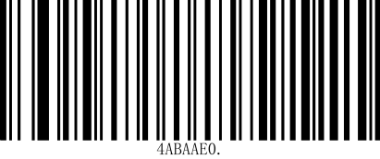

**\*Code 39 disable parity**

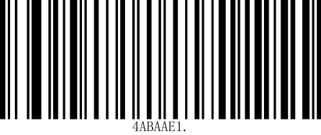

**Code 39 enables checksum, does not transmit checksum character**

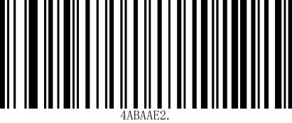

**enables parity check and transmits the parity character.**

When set to “Enable, do not transmit parity character”, if the data length is less than the minimum read length limit after deducting the 1-byte parity character, the code reading will fail.

For example, if the minimum code length of Code 39 in the current scanner setting is 4 bytes, and the parity character is not transmitted, then reading Code 39 with a total length of 4 bytes will fail!

### Code39 起始/结束符设置 Start/End Character Setting

Scanning the following setup codes will configure the Code39 start and end character output.

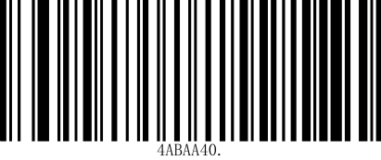

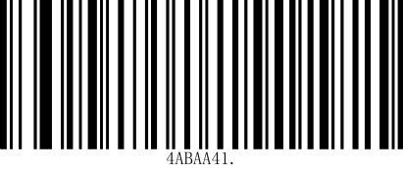

**Start/end character output**

**\*Starting/ending character not output**

### Code39 Full ASCII

Enabling Code 39 Full ASCII turns on the ability to read full ASCII characters.

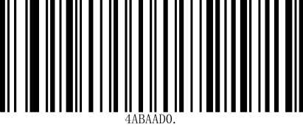

**\*Disable Full ASCII mode**

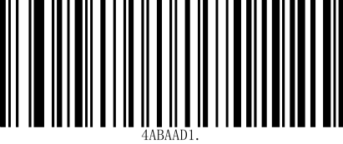

**Enable Full ASCII mode**

## Code32

### Code32 使能 Enable

Scanning the following setup codes will set up the Code32 barcode to allow/prohibit reading.

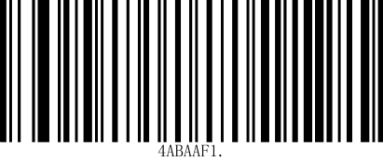

**Allow reading Code32**

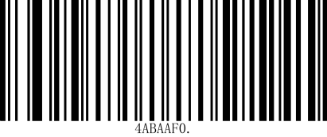

**Prohibit Code32**

## Code93

### Code93 使能 Enable

Scanning the following setup codes will set the Code93 barcode to allow/prohibit reading.

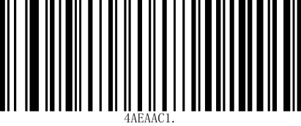

**\*Allow reading of Code93**

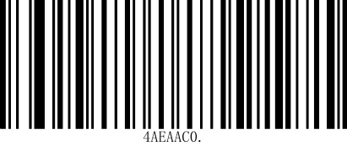

**Prohibit reading of Code93.**

### Code93 识读长度设置 Read Length Setting

Scanning the following setting code will set the minimum reading length of Code93 barcode.

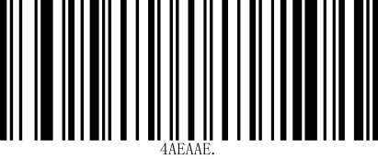

**Code93 Minimum message length**

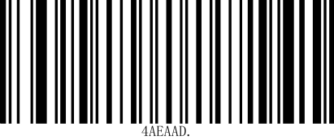

**Code93 Maximum message length**

## CodaBar

### CodaBar 使能CodaBar enable

Scanning the following setting code will set the allow/prohibit reading of CodaBar barcode.

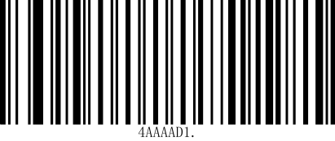

**\*CodaBar is allowed reading**

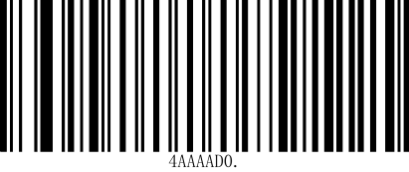

**Prohibit reading CodaBar**

### CodaBar 识读长度设置 CodaBar Read Length Setting

Scanning the following setup codes will set the minimum read length for CodaBar barcodes.

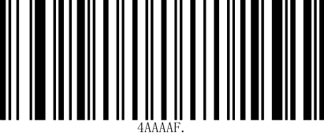

**CodaBar Message Minimum Length**

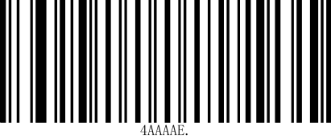

**Maximum CodaBar message length**

### CodaBar 校验设置(Mod-16) CodaBar Checksum Setting (Mod-16)

Codabar barcode data is not forced to contain the check character, if there is a check character, it must be the last byte of the data. If there is a check character, it must be the last byte of the data. The check character is the value calculated from all the data except the check character, which is used to check whether the data is correct or not.

* Set to “Disable Checksum” then the scanner will transmit all barcode data normally.
* Set to “Enable check, do not transmit check character”, the scanner will check the data according to the last bit of barcode, if the check passes, it will transmit normal data except the last check character, if the check fails, it will not transmit the barcode content.
* Set to “Enable parity, transmit parity character”, the scanner will parity according to the last bit of barcode data, if parity passes, the parity character will be transmitted as the last bit of normal data, if parity fails, no barcode content will be sent.

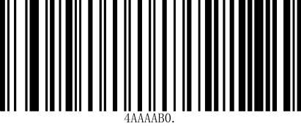

**\*Codabar Disable Checksum**

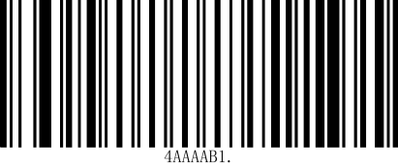

**Codabar enable parity, do not transmit parity character.**

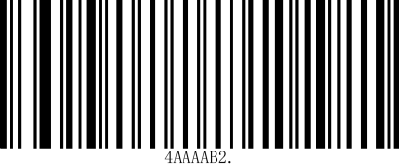

**Codabar enable parity, transmit parity character.**

When set to “Enable, do not transmit parity character”, if the data length is less than the minimum read length limit after deducting the 1-byte parity character, the code reading will fail. For example, if the minimum read length of Codabar in the current scanner setting is 4 bytes, and the parity character is not transmitted, then reading a Codabar with a total length of 4 bytes will fail!

### CodaBar 起始/结束符设置 Start/End Character Setting

The start and stop characters are one of the four characters “A”, “B”, “C”, “D”. You can set whether to transmit the start and stop characters together with the barcode data after successful reading. Scanning the following setup code will set the CodaBar barcode to allow/prohibit sending start and stop characters.

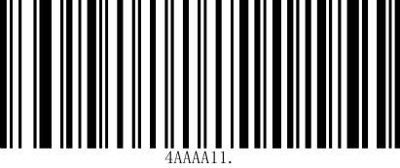

**Send CodaBar start/stop symbols**

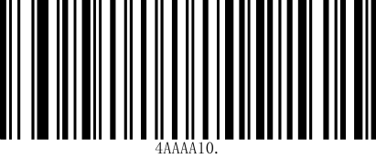

**\*No CodaBar start/stop symbols are sent.**

## Interleaved 2 of 5

### Interleaved 2 of 5 使能 Enable

Scanning the following setup codes will set the Interleaved 2 of 5 barcode to allow/prohibit reading.

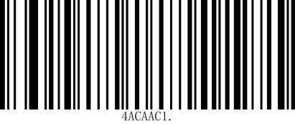

**Allow reading Interleaved 2 of 5**

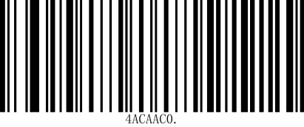

**Interleaved 2 of 5 barcode allow/prohibit reading.**

### Interleaved 2 of 5 识读长度设置 Interleaved 2 of 5 Read Length Setting

Scanning the following setting code will set the minimum read length for Interleaved 2 of 5 barcode.

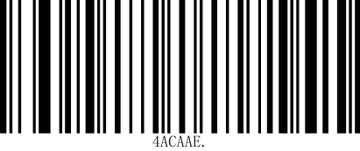

**The minimum length of the Interleaved 2 of 5 message is**

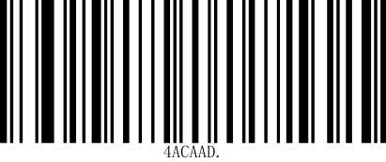

**\*The maximum length of Interleaved 2 of 5 message is**

### Interleaved 2 of 5 校验设置(Mod-10) Checksum Setting (Mod-10)

Interleaved 2 of 5 barcode data is not mandatory to include the check character, if there is a check character, it must be the last byte of the data. The check character is the value calculated from all data except the check character, which is used to check whether the data is correct or not.

* Set to “Disable Checksum” then the scanner will transmit all barcode data normally.
* Set to “Enable check, do not transmit check character”, the scanner will check the data according to the last bit of barcode, if the check passes, it will transmit normal data except the last check character, if the check fails, it will not transmit the barcode content.
* Set to “Enable check, transmit check character”, the scanner will check the barcode according to the last bit of data, if the check passes, the check character will be transmitted as the last bit of normal data, if the check fails, the barcode content will not be sent.

Interleaved 2 of 5 barcode must have even number of digits in the code, the check character is included in the code, if the code is odd number, then add 0 before the first digit, the check character is generated automatically during code making.

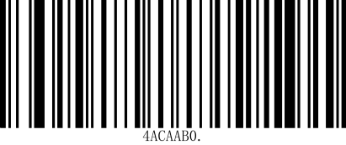

**\*Interleaved 2 of 5 Disable Check Characters**

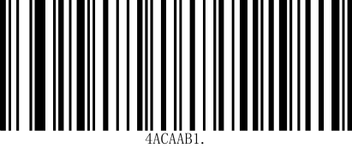

**Interleaved 2 of 5 enable parity check, do not transmit parity check character.**

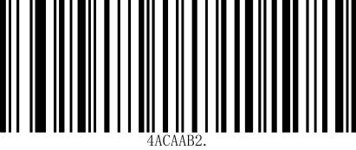

**Interleaved 2 of 5 enables parity check and transmits parity character.**

If the data length is less than the minimum read length limit after deducting the 1-byte parity character when the setting is set to not transmit the parity character, the read will fail.

For example, the current scanner setting of Interleaved 2 of 5 minimum read length. For example, if the Interleaved 2 of 5 minimum read length is 4 bytes in the current scanner setting, and no parity character is transmitted, reading a 4-byte Interleaved 2 of 5 will fail!

For example, if the current scanner setting for Interleaved 2 of 5 is 4 bytes and no checksum character is transmitted, reading Interleaved 2 of 5 with a total length of 4 bytes will fail!

## Industrial 2 of 5

### Industrial 2 of 5 Enable

Scanning the following setup codes will set the Industrial 2 of 5 barcode to allow/prohibit reading.

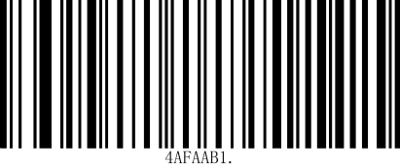

**Allow reading Industrial 2 of 5**

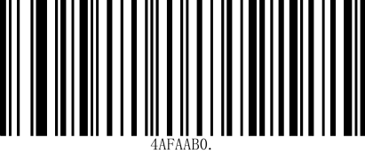

**\*Industrial 2 of 5 barcode is prohibited.**

### Industrial 2 of 5 识读长度设置 Read Length Setting

Scanning the following setup code will set the minimum read length for Industrial 2 of 5 barcode.

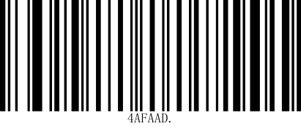

**The minimum length of the Industrial 2 of 5 message is 0.**

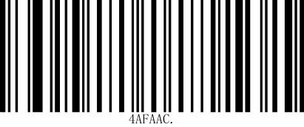

**\*Maximum length of Industrial 2 of 5 message.**

## Industrial 2 of 5

### Industrial 2 of 5 Enable

Scan the following barcode to allow or prohibit the reading of Industrial 2 of 5 barcodes.



**Allow reading Industrial 2 of 5**



**\*Prohibited from reading Industrial 2 of 5**

### Industrial 2 of 5 Reading length setting

Scan the following barcode to set the minimum reading length for the Industrial 2 of 5 barcode.



**Industrial 2 of 5 The minimum message length is 0**



**\*Industrial 2 of 5 Maximum message length**

## Matrix 2 of 5

### Matrix 2 of 5 Enable

Scan the following barcode to allow or prohibit Matrix 2 of 5 barcode reading.

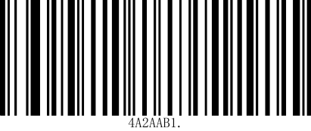

**Allow reading Matrix 2 of 5**

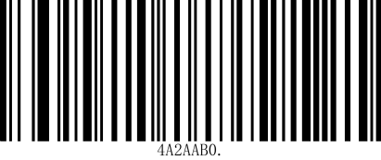

**\*Prohibited from readingMatrix 2 of 5**

### Matrix 2 of 5 Reading length setting

Scan the following barcode to set the minimum scan length for Matrix 2 of 5 barcodes.

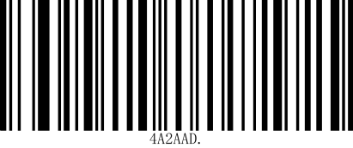

**Matrix 2 of 5 Minimum message length**

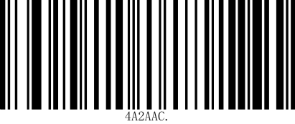

**\*Matrix 2 of 5 Maximum message length**

### Matrix 2 of 5 verification settings (Mod-10)

* The Matrix 2 of 5 barcode data does not have to include a check character. If there is a check character, it must be the last byte of the data. The check character is the value calculated from all the data except the check character, and is used to verify whether the data is correct.
* If set to "Disable Verification", the scanner will transmit all barcode data normally.
* If it is set to "Enable verification, do not transmit verification character", the scanner will verify the last digit of the barcode. If the verification passes, the normal data except the last verification character will be transmitted. If the verification fails, the barcode content will not be sent.
* If it is set to "Enable verification, transmit verification character", the scanner will verify according to the last digit of the barcode data. If the verification passes, the verification character will be transmitted together with the last digit of the normal data. If the verification fails, the barcode content will not be sent.

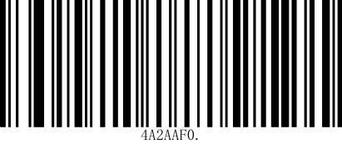

**\*Matrix 25 Disable verification**

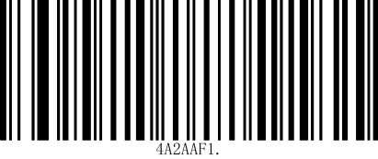

**Matrix 25 Enable verification**

When the check character is not transmitted, if the data length minus the 1-byte check character is less than the minimum read length limit, the code reading will fail. For example: In the current scanner settings, the minimum read length of Matrix 2 of 5 is 4 bytes. If the check character is not transmitted, the total length of Matrix 2 of 5 of 4 bytes will fail!

## Code11

### Code11 Enable

Scan the following setting code to set whether to allow or prohibit Code 11 barcode reading.

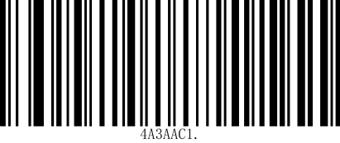

**Allow reading Code11**

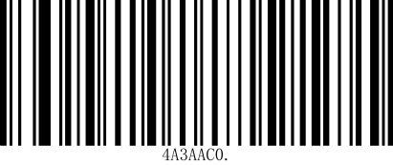

**\*Prohibited from reading Code11**

### Code11 Reading length setting

Scan the following setting code to set the shortest reading length of Code11 barcode.

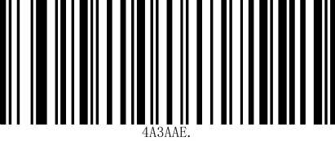

**Code11 Minimum message length**

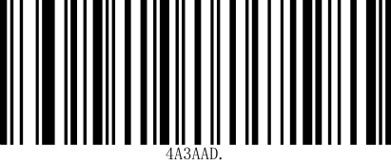

**Code11 Maximum message length**

### Code11 Verification Settings

Code 11 barcode data does not have to include a check character. If there is a check character, it can be the last 1 or 2 characters of the data. The check character is a value calculated based on all the data to verify whether the data is correct.

Therefore, if it is set to "Disable Verification", the scanner will transmit all barcode data normally.

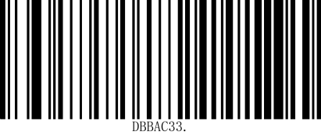

**\*Code11 Disable verification**

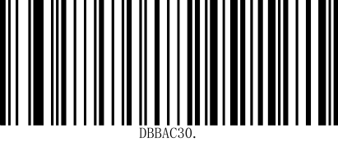

**Code11 One bit verification**

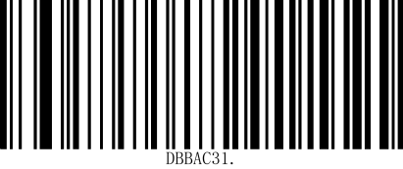

**Code11 Two bit verification**

## MSI-Plessey

### MSI-Plessey Enable

Scan the following setting code to set whether to allow or prohibit reading of MSI-Plessey barcodes.

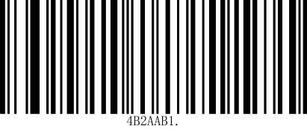

**Allow reading MSI**

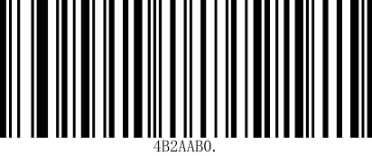

**\*Prohibited from reading MSI**

### MSI-Plessey Verification Settings

MSI-Plessey barcode data does not contain a check character. If there is a check character, it is the last 1 or 2 characters of the data. The check character is the value calculated from all data except the check character to verify whether the data is correct. If it is set to "Disable Check", the scanner will transmit all barcode data normally.

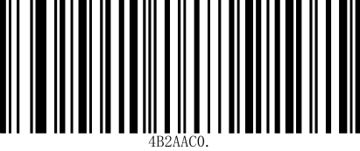

**Enable MOD10, but do not transmit**

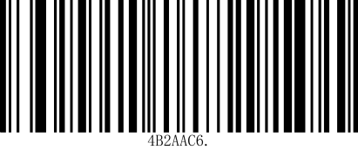

**Disable MSI checksum character**

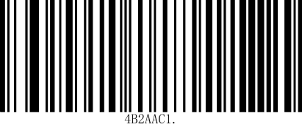

**Enable MOD10 and transmit characters**

### RSS-Limited Enable

Scan the following setting code to set whether to allow or prohibit the reading of limited RSS barcodes.

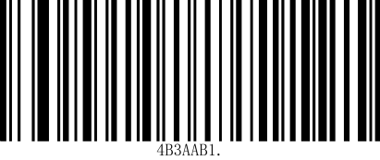

**Allow reading of restricted RSS**

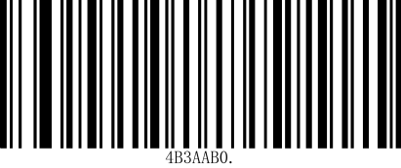

**\*Disable restricted RSS**

### RSS-Expaned Enable

Scan the following setting code to set whether to allow or prohibit the reading of extended RSS barcodes.

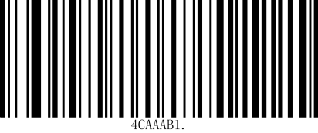

**Allow reading of extended RSS**

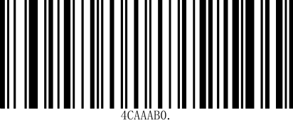

**\*Disable reading of extended RSS**

## Micro QR Code

### Micro QR Code Enable

Scan the following setting code to set whether to allow or prohibit Micro QR code reading.

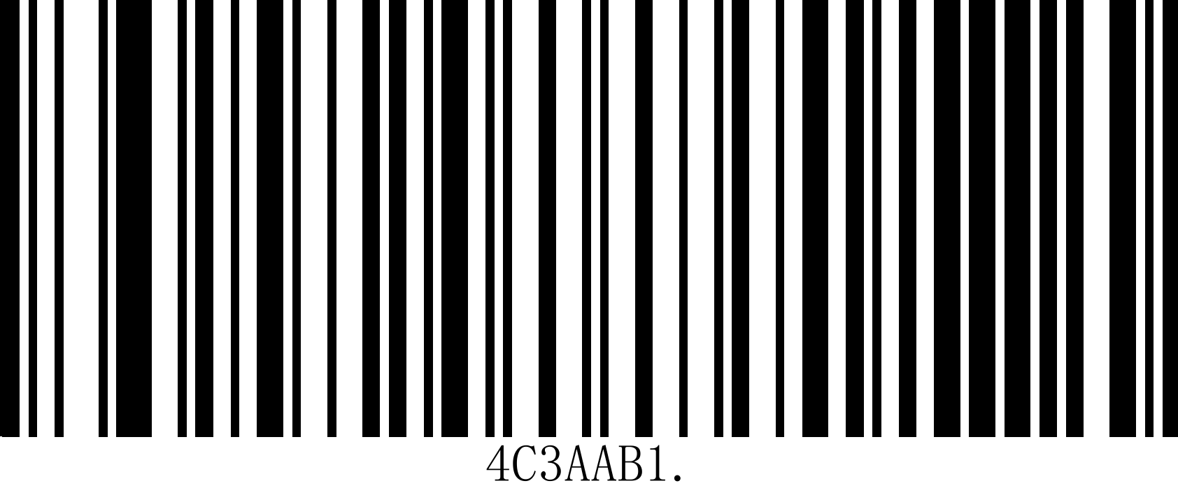

**Allow to read Micro QR**

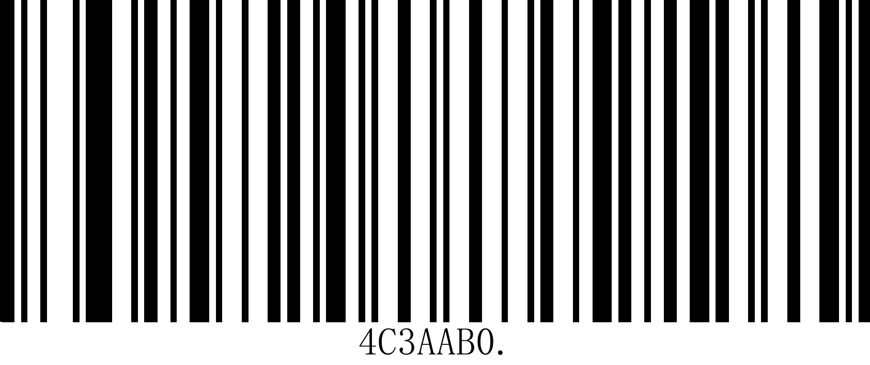

**\*Prohibit reading Micro QR**

## QR Code

### QR Code Enable

Scan the following setting code to set whether to allow or prohibit QR code reading.





**Prohibit reading QR**

## Data Matrix

### DM Code Enable

Scan the following setting code to set whether to allow or prohibit DM barcode reading. **\*Allow to read QR**

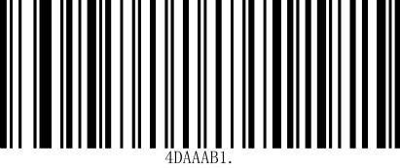

**\*Allow to read DM**

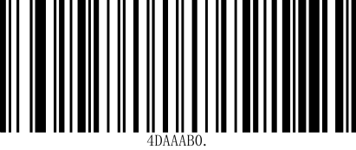

**Prohibit reading DM**

## PDF417

### PDF417 Enable

Scan the following setting code to set whether to allow or prohibit PDF417 barcode reading.

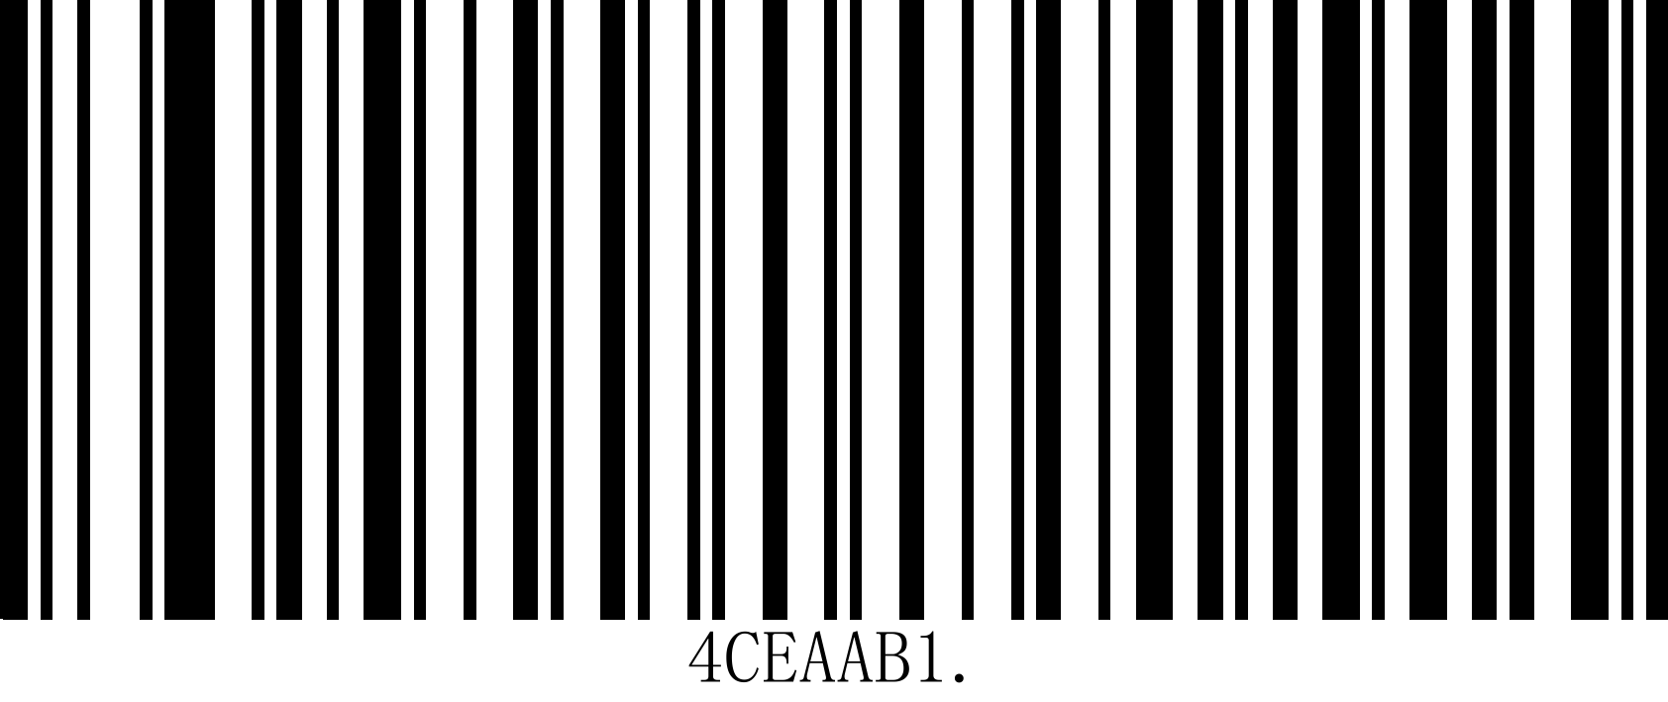

**\*Allow reading of PDF417**

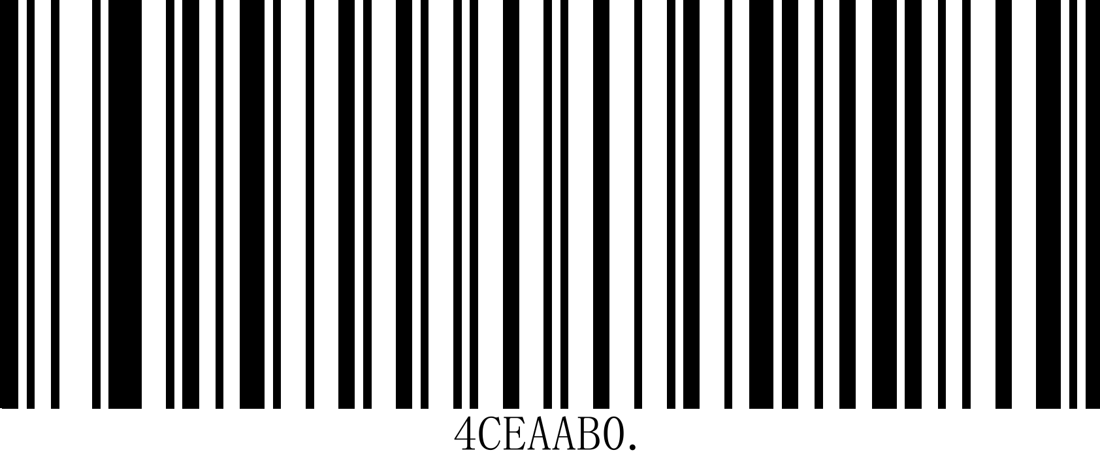

**Prohibit reading PDF417**

## Micro PDF417

### Micro PDF417 Enable

Scan the following setting code to set whether to allow or prohibit the reading of Micro PDF417 barcodes.



**Allow reading Micro PDF417**



**Prohibit reading Micro PDF417**

## Aztec Code

### Aztec Enable

Scan the following setting code to set whether to allow or prohibit the reading of Aztec codes.

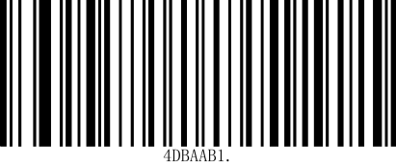

**Allow reading Aztec**

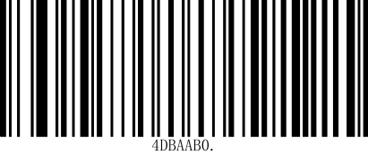

**Prohibit reading Aztec**

## Maxi Code

### Maxi Enable

Scan the following setting bar to set whether to allow or prohibit Maxi Code reading.

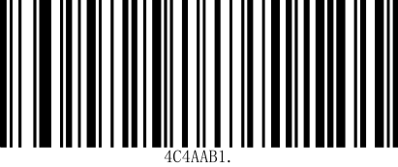

**Allow reading Maxi**

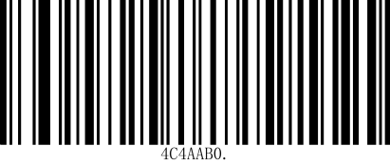

**\*Allow reading Maxi**

# Appendix B: AIM ID List

|  |  |  |
| --- | --- | --- |
| Barcode Type | AIM ID | Possible AIM ID qualifiers (m) |
| Aztec | ]z0 | 0 |
| Codabar | ]Fm | 0, 2, 4 |
| Code 39 | ]Am | 0, 1, 3, 4, 5, 7 |
| Code 93 | ]G0 | 0 |
| Code 128 | ]C0 | 0 |
| GS1 DataBar(RSS14) | ]e0 | 0 |
| GS1 DataBar Expanded | ]e0 | 0 |
| GS1 DataBar Limited | ]e0 | 0 |
| Data Matrix | ]d1 | 1 |
| EAN-8 | ]Em | 3, 4 |
| EAN-13 | ]Em | 0, 3 |
| UPC-A | ]Em | 0, 3 |
| UPC-E | ]Em | 0, 3 |
| Interleaved 2 of 5 | ]Im | 0, 1, 3 |
| Industrial 2 of 5 | ]S0 | 0 |
| Matrix 2 of 5 | ]X0 | 0 |
| PDF417 | ]L2 | 2 |
| Micro PDF417 | ]L2 | 2 |
| QR | ]Q1 | 1 |
| Micro QR | ]Q1 | 1 |
| MSI Plessey | ]Mm | 0, 1 |
| Code 11 | ]Hm | 0, 1, 3 |
| Code 32 | ]X0 | 0 |
| ISSN | ]X5 | 5 |
| ISBN | ]X4 | 4 |
| Maxicode | ]Um | 0, 1 |

Table 10-1 AIM ID List

Reference: ISO/IEC 15424-2008 Information technology - Automatic identification and data capture techniques - Data carrier identifiers (including symbolic identifiers).

# Appendix C: Code ID List

|  |  |
| --- | --- |
| Barcode Type | Code ID |
| Aztec | z |
| Codabar | a |
| Code 39 | b |
| Code 93 | i |
| Code 128 | j |
| GS1 DataBar(RSS14) | R |
| GS1 DataBar Expanded | R |
| Data Matrix | u |
| EAN-8 | d |
| EAN-13 | d |
| Interleaved 2 of 5 | e |
| Maxicode | x |
| PDF417 | r |
| QR | Q |
| UPC-A | c |
| UPC-E | c |
| Micro QR | Q |
| MSI Plessey | m |
| Industrial 2 of 5 | I |
| Matrix 2 of 5 | v |
| Code 11 | H |
| ISSN | g |
| ISBN | B |
| GS1 DataBar Limited | R |
| Micro PDF417 | s |
| Code 32 | b |

Table 11-1 Code ID List

# 11Appendix D: ASCII code list

|  |  |  |
| --- | --- | --- |
| hexadecimal | Decimal | Character |
| 00 | 0 | NUL (Null char.) |
| 01 | 1 | SOH (Start of Header) |
| 02 | 2 | STX (Start of Text) |
| 03 | 3 | ETX (End of Text) |
| 04 | 4 | EOT (End of Transmission) |
| 05 | 5 | ENQ (Enquiry) |
| 06 | 6 | ACK (Acknowledgment) |
| 07 | 7 | BEL (Bell) |
| 08 | 8 | BS (Backspace) |
| 09 | 9 | HT (Horizontal Tab) |
| 0a | 10 | LF (Line Feed) |
| 0b | 11 | VT (Vertical Tab) |
| 0c | 12 | FF (Form Feed) |
| 0d | 13 | CR (Carriage Return) |
| 0e | 14 | SO (Shift Out) |
| 0f | 15 | SI (Shift In) |
| 10 | 16 | DLE (Data Link Escape) |
| 11 | 17 | DC1 (XON) (Device Control 1) |
| 12 | 18 | DC2 (Device Control 2) |
| 13 | 19 | DC3 (XOFF) (Device Control 3) |
| 14 | 20 | DC4 (Device Control 4) |
| 15 | 21 | NAK (Negative Acknowledgment) |
| 16 | 22 | SYN (Synchronous Idle) |
| 17 | 23 | ETB (End of Trans. Block) |
| 18 | 24 | CAN (Cancel) |
| 19 | 25 | EM (End of Medium) |
| 1a | 26 | SUB (Substitute) |
| 1b | 27 | ESC (Escape) |
| 1c | 28 | FS (File Separator) |
| 1d | 29 | GS (Group Separator) |
| 1e | 30 | RS (Request to Send) |
| 1f | 31 | US (Unit Separator) |
| 20 | 32 | SP (Space) |
| 21 | 33 | ! (Exclamation Mark) |
| 22 | 34 | " (Double Quote) |
| 23 | 35 | # (Number Sign) |

Table 12-1 ASCII code list

|  |  |  |
| --- | --- | --- |
| hexadecimal | Decimal | Character |
| 24 | 36 | $ (Dollar Sign) |
| 25 | 37 | % (Percent) |
| 26 | 38 | & (Ampersand) |
| 27 | 39 | ` (Single Quote) |
| 28 | 40 | ( (Right / Closing Parenthesis) |
| 29 | 41 | ) (Right / Closing Parenthesis) |
| 2a | 42 | * (Asterisk) |
| 2b | 43 | + (Plus) |
| 2c | 44 | , (Comma) |
| 2d | 45 | - (Minus / Dash) |
| 2e | 46 | . (Dot) |
| 2f | 47 | / (Forward Slash) |
| 30 | 48 | 0 |
| 31 | 49 | 1 |
| 32 | 50 | 2 |
| 33 | 51 | 3 |
| 34 | 52 | 4 |
| 35 | 53 | 5 |
| 36 | 54 | 6 |
| 37 | 55 | 7 |
| 38 | 56 | 8 |
| 39 | 57 | 9 |
| 3a | 58 | : (Colon) |
| 3b | 59 | ; (Semi-colon) |
| 3c | 60 | < (Less Than) |
| 3d | 61 | = (Equal Sign) |
| 3e | 62 | > (Greater Than) |
| 3f | 63 | ? (Question Mark) |
| 40 | 64 | @ (AT Symbol) |
| 41 | 65 | A |
| 42 | 66 | B |
| 43 | 67 | C |
| 44 | 68 | D |
| 45 | 69 | E |
| 46 | 70 | F |
| 47 | 71 | G |
| 48 | 72 | H |
| 49 | 73 | I |
| 4a | 74 | J |
| 4b | 75 | K |
| 4c | 76 | L |
| 4d | 77 | M |

|  |  |  |
| --- | --- | --- |
| hexadecimal | Decimal | Character |
| 4e | 78 | N |
| 4f | 79 | O |
| 50 | 80 | P |
| 51 | 81 | Q |
| 52 | 82 | R |
| 53 | 83 | S |
| 54 | 84 | T |
| 55 | 85 | U |
| 56 | 86 | V |
| 57 | 87 | W |
| 58 | 88 | X |
| 59 | 89 | Y |
| 5a | 90 | Z |
| 5b | 91 | [ (Left / Opening Bracket) |
| 5c | 92 | \ (Back Slash) |
| 5d | 93 | ] (Right / Closing Bracket) |
| 5e | 94 | ^ (Caret / Circumflex) |
| 5f | 95 | _ (Underscore) |
| 60 | 96 | ' (Grave Accent) |
| 61 | 97 | a |
| 62 | 98 | b |
| 63 | 99 | c |
| 64 | 100 | d |
| 65 | 101 | e |
| 66 | 102 | f |
| 67 | 103 | g |
| 68 | 104 | h |
| 69 | 105 | i |
| 6a | 106 | j |
| 6b | 107 | k |
| 6c | 108 | l |
| 6d | 109 | m |
| 6e | 110 | n |
| 6f | 111 | o |
| 70 | 112 | p |
| 71 | 113 | q |
| 72 | 114 | r |
| 73 | 115 | s |
| 74 | 116 | t |
| 75 | 117 | u |
| 76 | 118 | v |
| 77 | 119 | w |

|  |  |  |
| --- | --- | --- |
| hexadecimal | Decimal | Character |
| 78 | 120 | x |
| 79 | 121 | y |
| 7a | 122 | z |
| 7b | 123 | { (Left/ Opening Brace) |
| 7c | 124 | | (Vertical Bar) |
| 7d | 125 | } (Right/Closing Brace) |
| 7e | 126 | ~ (Tilde) |
| 7f | 127 | DEL (Delete) |

QR code system

|  |  |  |  |  |
| --- | --- | --- | --- | --- |
| **Symbology** | AIM | |  | |
| **ID** | **Possible Modifiers**  **（m）** | **ID** | **Hex** |
| **All Symbologies** |  |  |  | **99** |
| **Aztec Code** | ]zm | 0-9, A-C | z | **7A** |
| **Chinese Sensible Code (Han Xin Code)** | ]X0 |  | H | **48** |
| **Codablock A** | ]O6 | 0, 1, 4, 5, 6 | V | **56** |
| **Codablock F** | ]Om | 0, 1, 4, 5, 6 | q | **71** |
| **Code 49** | ]Tm | 0, 1, 2, 4 | l | **6C** |
| **Data Matrix** | ]dm | 0-6 | w | **77** |
| **GS1** | ]em | 0-3 | y | **79** |
| **GS1 Composite** | ]em | 0-3 | y | **79** |
| **GS1**  **DataBar Omnidirecti onal** | ]em | 0-3 | y | **79** |
| **MaxiCode** | ]Um | 0-3 | x | **78** |
| **PDF417** | ]Lm | 0-2 | r | **72** |
| **MicroPDF417** | ]Lm | 0-5 | R | **52** |
| **QR Code** | ]Qm | 0-6 | s | **73** |
| **Micro QR Code** | ]Qm |  | s | **73** |

Postal Code

|  |  |  |  |  |
| --- | --- | --- | --- | --- |
| **Symbology** | AIM | |  | |
| **ID** | **Possible Modifiers**  **（m）** | **ID** | **Hex** |
| **All Symbologies** |  |  |  | **99** |
| **Australian Post** | ]X0 |  | A | **41** |
| **British Post** | ]X0 |  | B | **42** |
| **Canadian Post** | ]X0 |  | C | **43** |

|  |  |  |  |  |
| --- | --- | --- | --- | --- |
| **Symbology** | AIM | |  | |
| **ID** | **Possible Modifiers**  **（m）** | **ID** | **Hex** |
| **China Post** | ]X0 |  | Q | **51** |
| **InfoMail** | ]X0 |  | , | **2c** |
| **Intelligent Mail Bar Code** | ]X0 |  | M | **4D** |
| **Japanese Post** | ]X0 |  | J | **4A** |
| **KIX (Netherlands) Post** | ]X0 |  | K | **4B** |
| **Korea Post** | ]X0 |  | ? | **3F** |
| **Planet Code** | ]X0 |  | L | **4C** |
| **Postal-4i** | ]X0 |  | N | **4E** |
| **Postnet** | ]X0 |  | P | **50** |

# 11Appendix E: Data Code

0 ~ 9

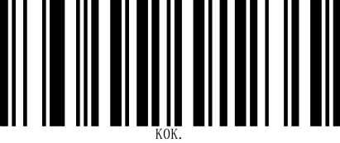

0

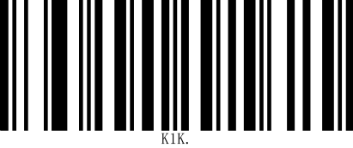

1

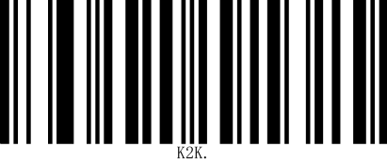

2

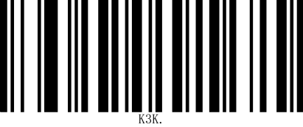

3

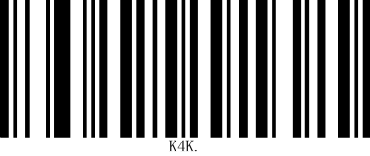

4

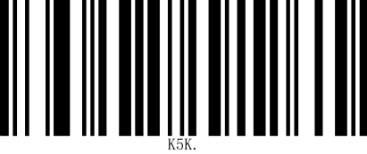

5

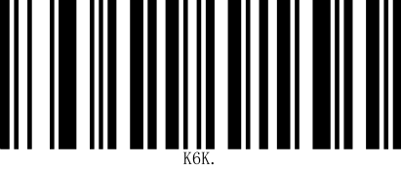

6

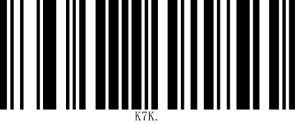

7

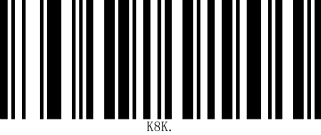

8

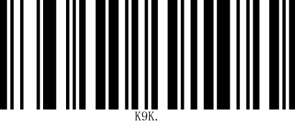

9

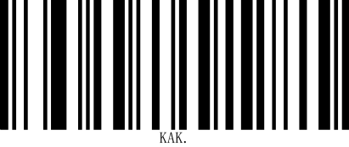

A

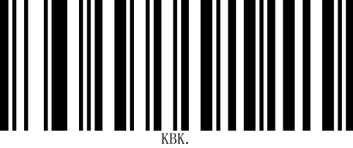

B

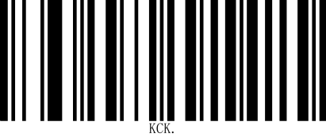

C

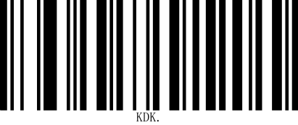

D

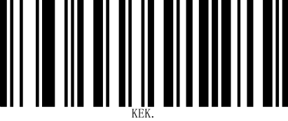

E

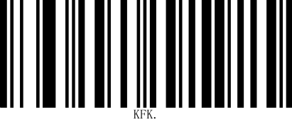

F

# 11 Appendix F: Save or Cancel

After scanning the data code, you need to scan the "Save" setting code to save the scanned data. If you make a mistake when scanning the data code, you can cancel scanning the wrong data.

For example, if you scan a certain setting code and scan the data "A", "B", "C", and "D" in sequence, if you scan "Cancel the last read data", the last read digit "D" will be canceled. If you scan "Cancel the previous read data", the scanned data "ABCD" will be canceled. If you scan "Cancel modification settings", the scanned data "ABCD" will be canceled and the modification settings will be exited.

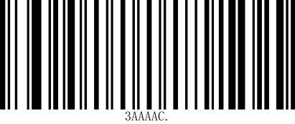

**Save**

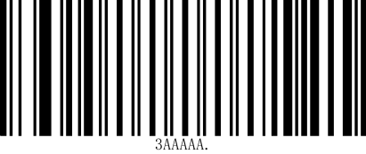

Cancel